Intro to Programming (Python)

Assignment 02

# Overview

In this activity, you learn about built-in functions and operators, what are they, and how you use them. You also learn how to create demonstration scripts and document your knowledge.

This assignment includes the following tasks:

1. Watch the module videos.
2. Read a book chapter.
3. Review some web pages.
4. Watch the additional videos.
5. Apply your knowledge.
6. Document your knowledge.
7. Submit your work.

**Tip:** Consider the following questions while you work through the module to help you focus:

* What is data?
* How do you declare and assign values to constants and variables?
* How do you work with data types?
* What are Functions (Methods)?
* What are Operational Constructs (Operators)?
* How do you use concatenation?
* What is the difference between value and reference types?

# Assignment Steps

The following assignment steps ask you to read about, perform, and write about programming.

***Note:*** *Course assignments help you learn through* ***reading****,* ***watching*** *demonstrations,* ***performing*** *programming in Python, and reflecting on what you learned through* ***writing****. You are strongly encouraged to continue your learning by experimentation.*

## Step 1 - Watch my Video Lecture

Please watch my course lecture for this module. You can find this module lecture(s) here: [ITFdn 110 - Python Course Videos](https://youtube.com/playlist?list=PLfycUyp06LG9fZllIqBrxLcNV4CR50HEX)

Please watch these additional videos as well:

* Variables - <http://www.youtube.com/watch?v=667ZeuZ0Q8M> (external site)
* Python Tutorial for Beginners 2: Strings - Working with Textual Data <https://youtu.be/k9TUPpGqYTo> (external site)

## Step 2 - Read a book chapter

Please **read chapter two** in your textbook. You **do not have to perform the exercises or type in the code**, but it is best if you open the script files as you read about them. You can find the downloadable **book files** **on Canvas** for your convenience.

## Step 3 - Review the following web pages

Please review the following web pages:

1. <http://www.learnpython.org/en/Variables_and_Types>(external site)
2. <http://www.learnpython.org/en/Basic_Operators>(external site)

## Step 4 - Apply your knowledge

Now that you have reviewed the websites and videos, try to create a new program that asks the user to input 2 numbers then prints out **the sum, difference, product, and quotient**.

### Step 4.1 Create a Python Script

Create a python script file with the code shown in Figure 1.

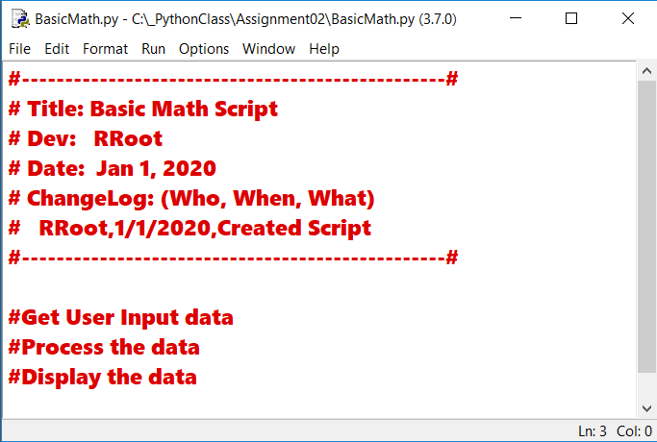

Figure 1. The code in BasicMath.py

### Step 4.2 Save your script to a folder

Save the python script **file** **as** **BasicMath.py** in a **new sub-folder** **called _PythonClass\Assignment02 (**you created the folder you created the **_**PythonClass folder in Module 01). Please use the C: Drive on a Windows OS or the Documents folder on a Mac OS (using the Desktop on either OS is not recommend).

### Step 4.3 Run Your Script

Add code to the script to capture user input data, process that data, and display the resulting data.

### Step 4.4 Run Your Script

With the script created and saved in the proper location, run the script in an OS command/shell window, and capture an image of it working on your computer (Figure 2).

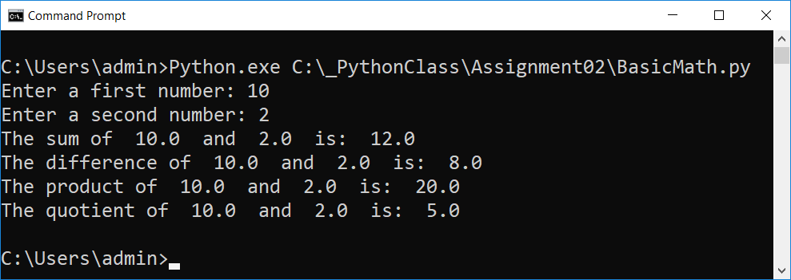

Figure 2: A screenshot of the script running in a command window.

## Step 5 - Document your knowledge

After you have created and tested your Python script, create a document describing the steps you took in performing this assignment.

**Notes:**

* All resources for this assignment are found in the lectures, recommended reading, or recordings specified in the class syllabus. You do not need to locate additional resources outside of these.
* Your document **must look professional** to get full points! Use my example template and video, in the General Files and Topics module, as a guide for what I expect a professional paper to look like. Make sure you format it like a college paper instead of a text message. Things like your **name, date, class, citations, introductory and summary paragraphs** are always expected! So, not putting these in the document will cost you! ([*See this video for help*](https://youtu.be/9ojhSW9ljjo)!)
* Please **save** your files as a PDF file called **Assignment02_YourNameHere.pdf.** Here is an example from Google Docs, but it is similar in most text editors!

**Important**: Make sure to include an introduction and summary, as well as a heading. It does not have to be perfect, but you won't get credit for it if you turn in a simple blob of text! watch this video to help you understand what I am looking for: [Creating Professional Documents](https://youtu.be/9ojhSW9ljjo)

## Step 6 - Submit your work

Now place your document with the Python script in the Assignment02 folder, then Zip this folder into a “.zip” file before finally uploading the file to the class assignment page on Canvas.

Congratulations! You are done!